Option#2: Implementing R Hypothesis Testing

Sonya E. Ghebrechristos

MIS500: Foundations of Data Analytics

CSU-Global

Mills, Jamia

12/08/2019

1. The Code

**tScore_before <- c(40, 62, 74, 22, 64, 65, 49, 49, 49)**

**tScore_after <- c(68, 61, 64, 76, 90, 75, 66, 60, 63)**

**# Create a data frame**

**my_data <- data.frame(**

**group = rep(c("Score Before", "Score After"), each = 9),**

**scores = c(tScore_before,  tScore_after)**

**)**

**# Print all data**

**print(my_data)**

: The (Screenshot) output

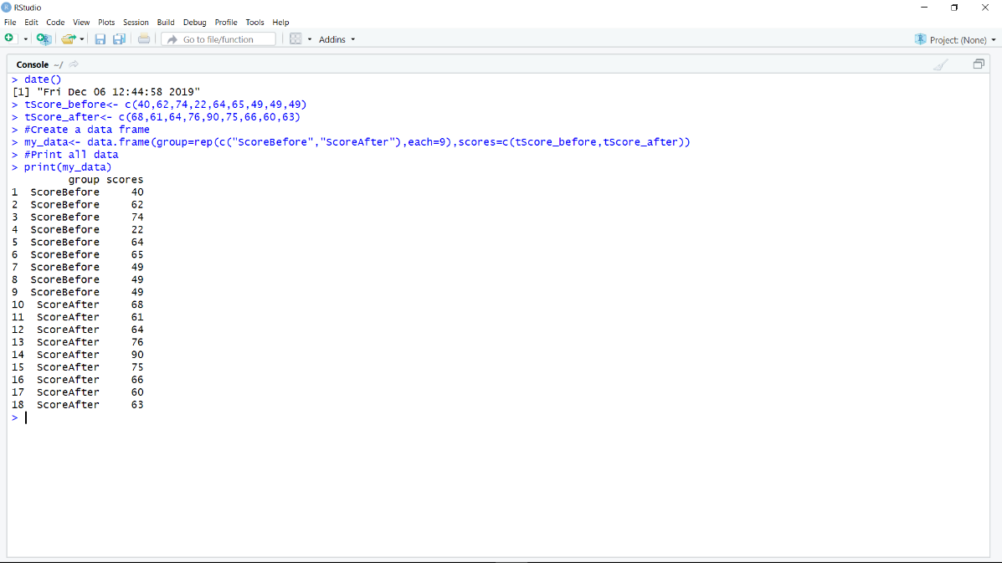

1. Code()

# Compute summary statistics by groups

library(dplyr)

group_by(my_data, group) %>%

  summarise(

    count = n(),

    mean = mean(scores, na.rm = TRUE),

    sd = sd(scores, na.rm = TRUE)

  )

The (Screenshot) output

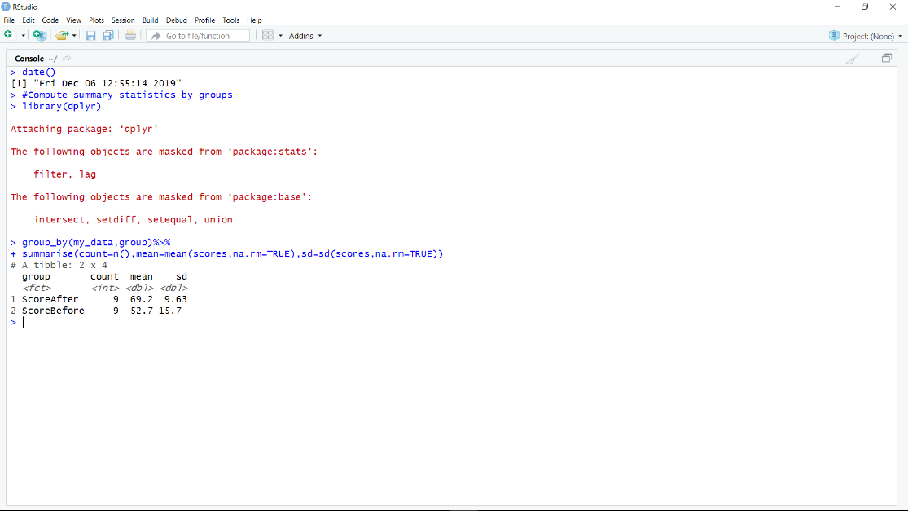

1. Code

**# Compute Unpaired Two Sample t-test**

**res <- t.test(tScore_before, tScore_after, var.equal = TRUE)**

**res**

**The (screenshot) output**

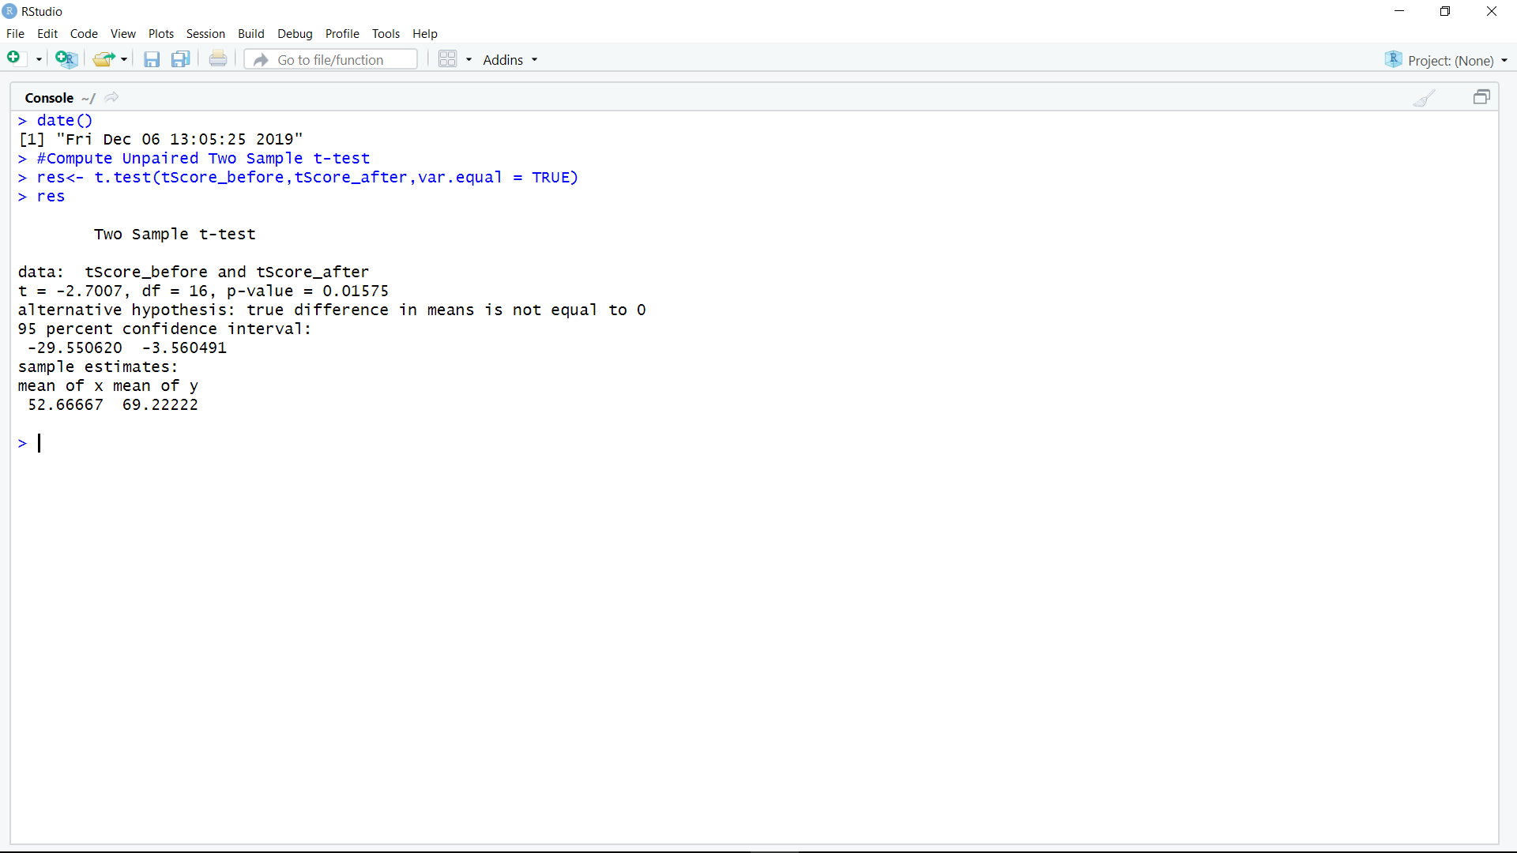

1. Code(

#Compute independent t-test

res <- t.test(scores ~ group, data = my_data, var.equal = TRUE)

res

The (screenshot) output

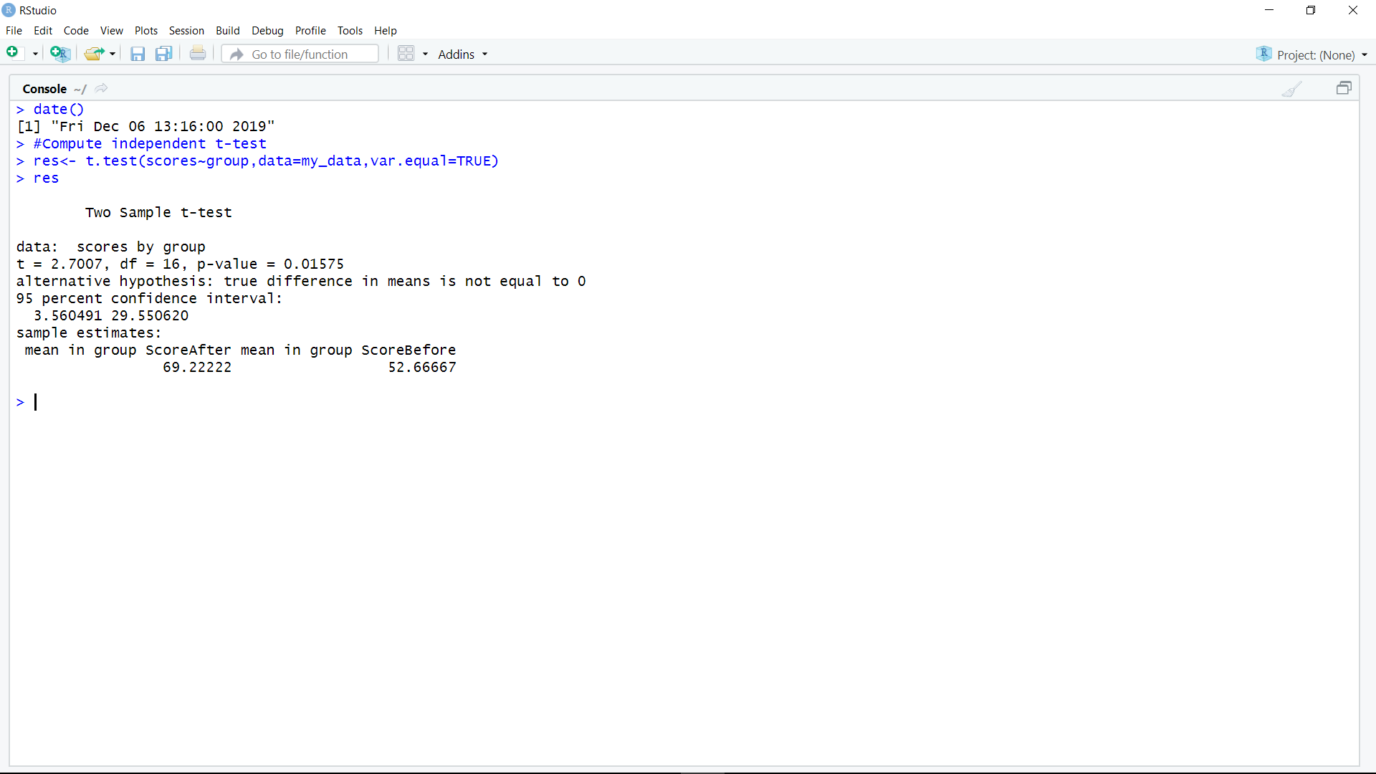

1. Code

**#test whether the average score before score is less than the average after score, type this:**

**t.test(scores ~ group, data = my_data,**

**var.equal = TRUE, alternative = "less")**

The (screenshot) output

